Technical draft for CloudLab
This is the draft architecture design of student project, which needs to be reviewed, simplified and optimised based on the provided cloud platform and best practices.
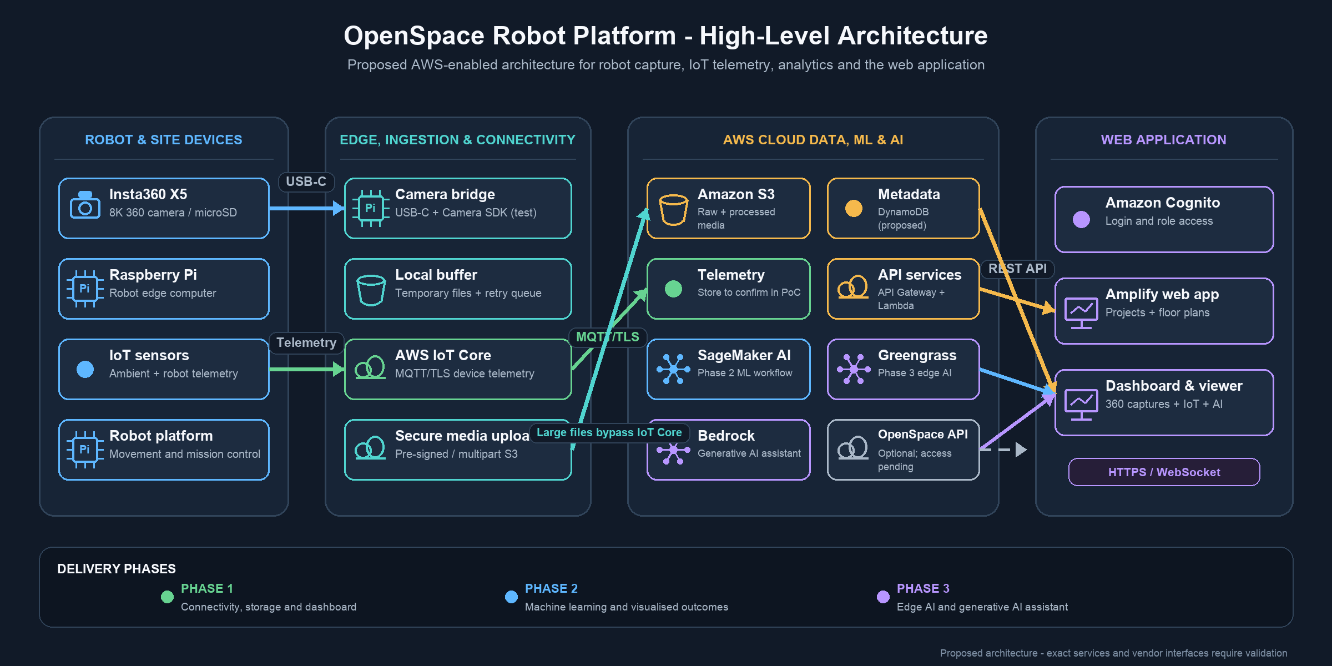
Phase I — IoT cloud platform (end-to-end connectivity and visualization)
Raspberry Pi + AWS IoT + Cloud Data + React Frontend
AWS IoT Core, Amazon Timestream, Amazon S3, Amazon API Gateway, AWS Amplify
Phase II — Add AI ML and Inference (ML outcome)
ML Analytics
Amazon SageMaker AI
Phase III — Generative/agentic AI (AI assistant/AI Agent)
Amazon Bedrock AgentCore

This project may integrate five main AWS areas:
- Device ingestion – A Raspberry Pi can collect readings from the sensors in the PSB laboratory and publish the data to AWS IoT Core through MQTT. IoT rules can then route the readings to Amazon Timestream for time-series data or Amazon S3 for longer-term storage.

- Machine-learning model training and deployment – Amazon SageMaker AI can be used to prepare data, train a suitable model and evaluate the results. A small model such as XGBoost may be a practical starting point. Depending on the project requirements, predictions could be produced by batch jobs, serverless inference, a real-time endpoint, or an edge deployment using AWS IoT Greengrass.

- AI assistant – Amazon Bedrock can provide the foundation model for a future assistant. For the first prototype, the web application could send a request through Amazon API Gateway and AWS Lambda, which would call a Bedrock model and approved project data tools. If the project later needs a more complete agent workflow, Strands Agents with Amazon Bedrock AgentCore is the current AWS direction.

- Frontend and API – The frontend may be developed with React or Vue and hosted through AWS Amplify. Amazon API Gateway and AWS Lambda can provide a small serverless API for sensor data, machine-learning results and assistant requests.

- User interaction – Users could view recent readings and analysed results on the dashboard. In a later phase, they may also ask the assistant natural-language questions such as whether a reading is unusual, what changed during a selected period, or which area should be checked.

Category | AWS Service | Role | Comments
🔴 Mandatory / Core | AWS IoT Core | Receives MQTT/device data from Raspberry Pi/sensors | Core IoT entry point
🔴 Mandatory / Core | Amazon S3 | Stores files, images, datasets, ML outputs | Essential general-purpose storage
🔴 Mandatory / Core | AWS Lambda | Serverless backend/data processing | Good for lightweight processing and integration
🔴 Mandatory / Core | IAM | Users, roles and access permissions | Essential AWS security foundation
🟠 Necessary | Amazon API Gateway | Provides APIs between React/backend/cloud services | Needed if dashboard/application uses REST APIs
🟠 Necessary | Amazon Timestream for InfluxDB | Stores time-series sensor data | Very useful for IoT telemetry
🟠 Necessary | Amazon CloudWatch | Logs, monitoring and troubleshooting | Important during development
🟠 Necessary | Amazon Cognito | Authentication for web application | Needed when dashboard has user login
🟠 Necessary | AWS Amplify | Hosts/deploys React frontend | Convenient for student React dashboard
🟡 AI/ML Phase | Amazon SageMaker AI | ML training, experimentation and deployment | Add after basic IoT pipeline works
🟡 AI/ML Phase | Amazon Bedrock AgentCore | Infrastructure/services for deploying and operating AI agents | Add when developing the AI-agent component
🟡 Useful / Security | AWS Secrets Manager | Securely stores API keys/passwords/secrets | Recommended once external APIs/credentials are involved

